Question-3
Code:
#------ Importing libraries ------
import numpy as np
import matplotlib.pyplot as plt
import math
from mpl_toolkits.mplot3d import Axes3D

#------ Defining function ------
def E(x, y, z):
return np.sin(np.pi * x) * np.cos(np.pi * y) # Use numpy functions for element-wise operations

#------ x & y values ------
x = np.linspace(0, 0.25, 100)
y = np.linspace(0.25, 0.5, 100)
X, Y = np.meshgrid(x, y) # Generate meshgrid for X and Y

Z = E(X, Y, 0) # Calculate Z values using the function E

#------ Plotting surface ------
figure = plt.figure()
graph = figure.add_subplot(111, projection='3d')
graph.plot_surface(X, Y, Z, cmap='cividis')

#------ Labelling ------
graph.set_xlabel('X')
graph.set_ylabel('Y')
graph.set_zlabel('Z')
graph.set_title('Question - 3')

plt.show()

Graph:
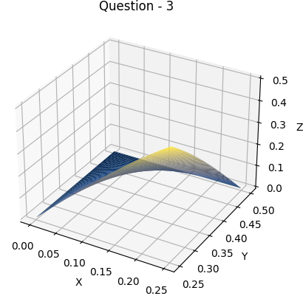

Question-7(a)
Code:
#------ Importing libraries ------
import numpy as np
import matplotlib.pyplot as plt
import math
from mpl_toolkits.mplot3d import Axes3D

#------ Defining functions ------
def E1(x, y, z):
return pow(x, 2) + pow(y, 2)

def E2(x, y, z):
return 3 * pow(x, 2) + 2 * pow(y, 2) + pow(z, 2)

#------ x & y values ------
x = np.linspace(-10, 10, 100)
y = np.linspace(-10, 10, 100)
X, Y = np.meshgrid(x, y)

#------ Calculate Z values for both functions ------
Z1 = E1(X, Y, 0)
Z2 = E2(X, Y, 0)

#------ Plotting surface ------
figure = plt.figure()
graph = figure.add_subplot(111, projection='3d')

#------ Plotting surface for first function ------
surf1 = graph.plot_surface(X, Y, Z1, cmap='cividis')

#------ Plotting surface for second function ------
surf2 = graph.plot_surface(X, Y, Z2, cmap='viridis')

#------ Labelling ------
graph.set_xlabel('X')
graph.set_ylabel('Y')
graph.set_zlabel('Z')
graph.set_title('Question - 7(a)')

#------ Creating a 2D plot for the legend ------
d1 = plt.Line2D([0], [0], linestyle="none", marker='o', markersize=10, markerfacecolor='orange')
d2 = plt.Line2D([0], [0], linestyle="none", marker='o', markersize=10, markerfacecolor='blue')
plt.legend([d1, d2], ['Function 1', 'Function 2'])

plt.show()
Graph:
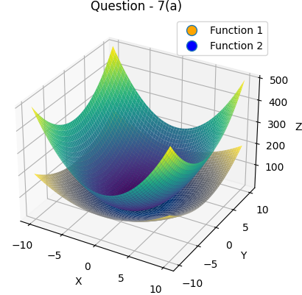
Question-8(a)
Code:
#------ Importing libraries ------
import numpy as np
import matplotlib.pyplot as plt
import math
from mpl_toolkits.mplot3d import Axes3D

#------ Defining function ------
def E(x, y, z):
return x*pow(math.e, x*y)

#------ x & y values ------
x = np.linspace(-1.5, 1.5, 100)
y = np.linspace(-1.5, 1.5, 100)
X, Y = np.meshgrid(x, y)

Z = E(X, Y, 0)

#------ Plotting surface ------
figure = plt.figure()
graph = figure.add_subplot(111, projection='3d')
graph.plot_surface(X, Y, Z, cmap='cividis')

#------ Labelling ------
graph.set_xlabel('X')
graph.set_ylabel('Y')
graph.set_zlabel('Z')
graph.set_title('Question - 8(a)')

plt.show()

Graph:
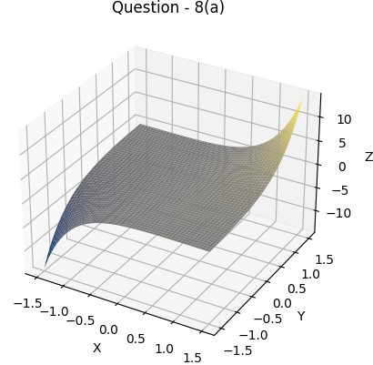

Question-10
Code(Solution):
#from sympy import symbols, integrate, exp, Abs

x, y = symbols('x y')

# Function definition
expr = (10000 * exp(y)) / (1 + Abs(x) / 2)

# x limits:
a = -5
b = 5

# y limits:
c = -2
d = 0

# Integration:
in_1 = integrate(expr, (x, a, b)) # integrate wrt x
in_2 = integrate(in_1, (y, c, d)) # integrate wrt y

# Simplifying result
result = in_2.evalf()

# Printing
print("Result =", result)

Output:
Result = 43328.7974930283
Code(Graph):
#------ Importing libraries ------
import numpy as np
import matplotlib.pyplot as plt
import math
from mpl_toolkits.mplot3d import Axes3D

#------ Defining function ------
def E(x, y, z):
return (10000*pow(math.e,y)) / (1+abs(x)/2)

#------ x & y values ------
x = np.linspace(-5, 5, 100)
y = np.linspace(-2, 0, 100)
X, Y = np.meshgrid(x, y)

Z = E(X, Y, 0)

#------ Plotting surface ------
figure = plt.figure()
graph = figure.add_subplot(111, projection='3d')
graph.plot_surface(X, Y, Z, cmap='cividis')

#------ Labelling ------
graph.set_xlabel('X')
graph.set_ylabel('Y')
graph.set_zlabel('Z')
graph.set_title('Question - 10')

plt.show()

Graph:
